Advantages: It can find non-linearly seperable clusters, which can’t be done using k-means. Other advantages are shown below.

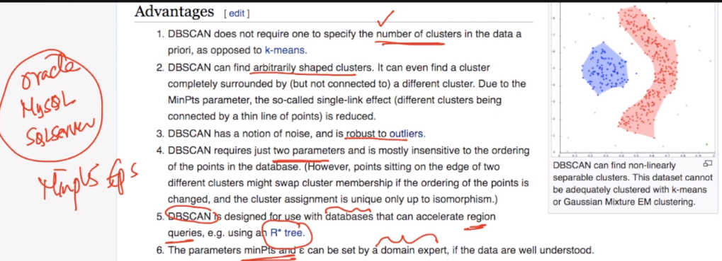

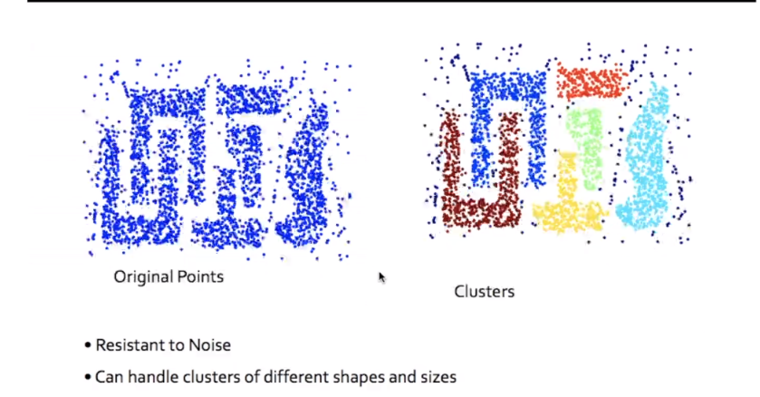

Disadvantages:

* It doesn’t work well for dataset with varying densities.
* Since It’s based on calculating distances for labeling point as core, border or noise. DBSCAN will not work well for high dimensions data(like text data) because of curse of dimensionality.
* It’s very sensitive to hyperparameter.

Below image shows example where by just changing EPS slightly the whole clusters get’s changed because there are variations in densities.

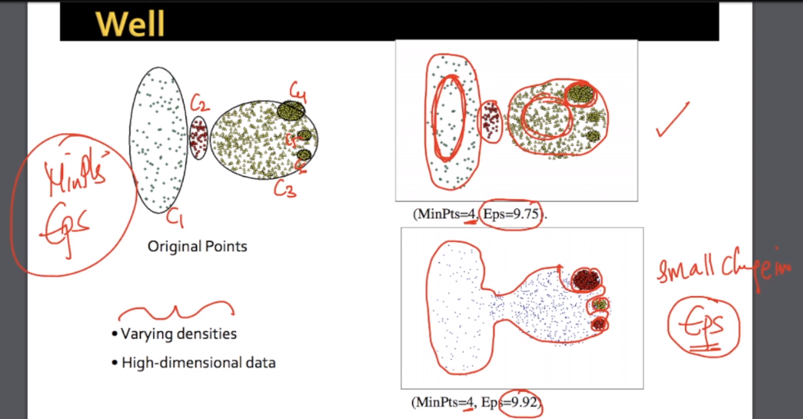

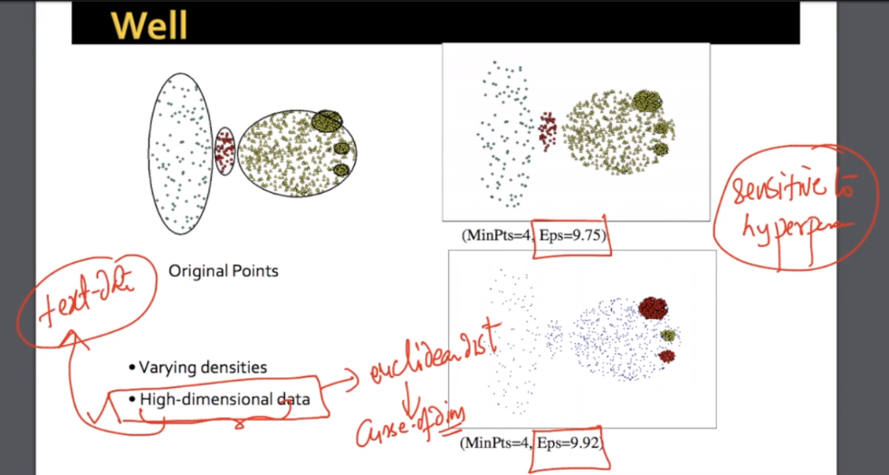

One more example of change eps slightly results in different clusters because of different densities.

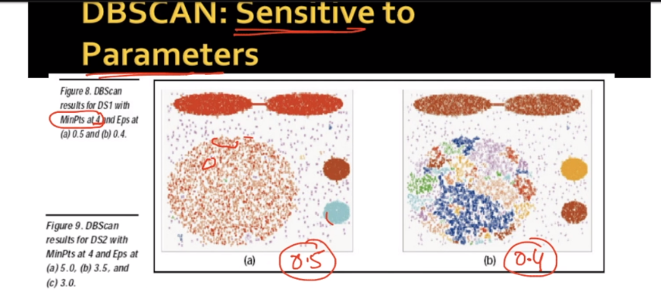

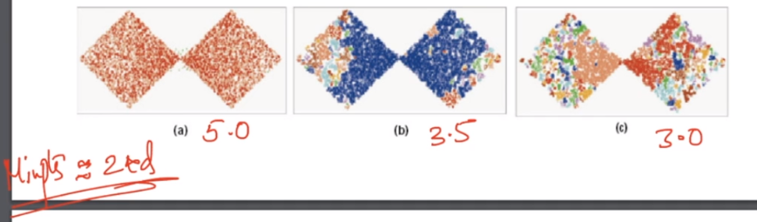

More disadvantages are mentioned below.

